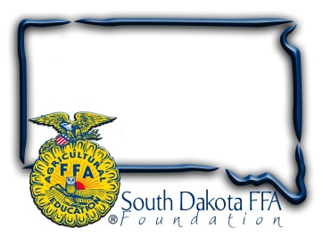

**For Immediate Release**

Contact: Gerri Ann Eide

605-765-4865

[gerri@sdffafoundation.org](mailto:gerri@sdffafoundation.org)

[Gerri@sdffafoundation.org](mailto:Gerri@sdffafoundation.org)

**For Immediate Release**

**SD FFA Highlights Agriculture with Ag Adventure Zone**

SD FFA is highlighting agriculture in the Rodeo Zone during Rodeo Rapid City, Jan. 31-Feb. 8, 2025. The Ag Adventure Zone is sponsored by South Dakota Farmers Union through the SD FFA Foundation. “Teaming up with FFA to provide hands-on education about South Dakota’s number one industry is important to the future of agriculture in South Dakota,” said Karla Hofhenke, Executive Director of South Dakota Farmers Union. “The Ag Adventure Zone connects consumers to the work South Dakota’s family farmers, ranchers and other ag professionals do each and every day to help feed and fuel the nation.”

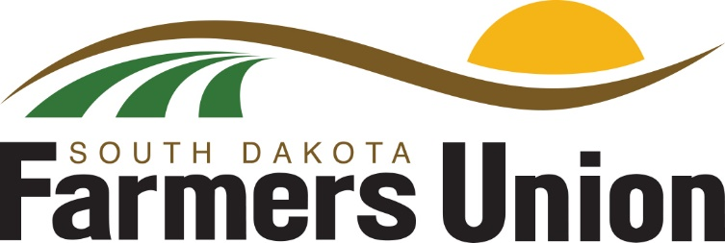

Located in the Ice Arena at The Monument, in Rapid City, the Ag Adventure Zone will illustrate the diversity of South Dakota agriculture, with interactive and educational exhibits on beef, swine, grain, and more from production to processing. Hands on lessons will occur around veterinary science and plant production. The Ag Adventure Zone’s mission is to: showcases modern agricultural practices, communicates commitment to natural resources and demonstrates wholesome, safe food production for all ages. Industry volunteers, State FFA officers and District 5 FFA members will be at the Ag Adventure Zone to host activities and interact with Black Hills Stock Show attendees.

“We are extremely grateful for South Dakota Farmers Union and Sutton Rodeo investing in the South Dakota FFA to make this agricultural education event at Rodeo Rapid City possible. Our partnership is tremendous as we educate FFA members and the public about agriculture, creating informed consumers,” says South Dakota FFA Foundation Director Gerri Eide.

The SD FFA is also hosting “FFA Day” on Monday, February 3rd, as part of Rodeo Rapid City. High school FFA members from South Dakota, Nebraska, and Wyoming will attend interactive presentations, learning from industry leaders on topics in four agriculture pathways: animal systems, plant systems, power/structural systems and advocacy/ communications. Presenters include: SD Pork Producers, SD Beef Industry Council/Wall Meats, SD Sheep Growers Association, SD Soil Health Coalition, SD Florists Association, RDO Equipment, Agtegra Innovation Center, RDO Equipment, Focus Marketing Group and NewsCenter1. FFA members will gain insight into current agricultural practices and innovations and ask the experts questions. Members will also have the opportunity to attend a FFA SAE development, attend a livestock judging school, livestock judging contest, cattle shows and sales, and visit vendors.

The SD FFA Foundation is proud to support Agricultural Education and the FFA's mission to make a difference in the lives of students by developing their potential for *premier leadership*, *personal growth* and *career success* through agricultural education. For more information about the South Dakota FFA Foundation and South Dakota's FFA programs, visit [www.sdffafoundation.org](http://www.sdffafoundation.org/) or follow us on Facebook.

###